16 Creating Custom Geometry
12/14/2026

Extruding From an Edge
We can create Custom Geometry to fill unique areas of our mesh. Here we are selecting just 2 vertices and extruding them (E Key on Keyboard). Then you can use scale (S), rotate (R) and the move tool (G) to mold this new face to fit the area that you are needing to fill exactly.
Then hit the F key on the keyboard, and fill that new piece of topology. So, now you have created a brand-new custom face.
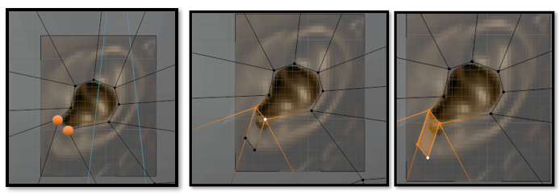
We can create the second face by selecting the two vertices at the side of this new face hitting the E key on the keyboard and extruding it again.
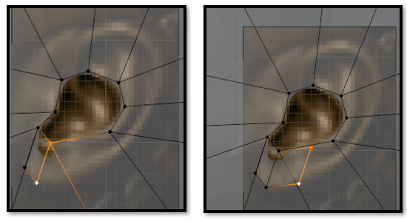
Watch It- Remember to keep checking things from different angles to make sure you are fitting the face correctly.

Here we continue to build what we need.
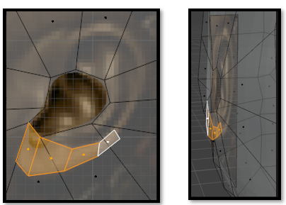

Extruding from a Vertex
We can also extrude (E) from a single vertex. Hit (F) to fill with a face.
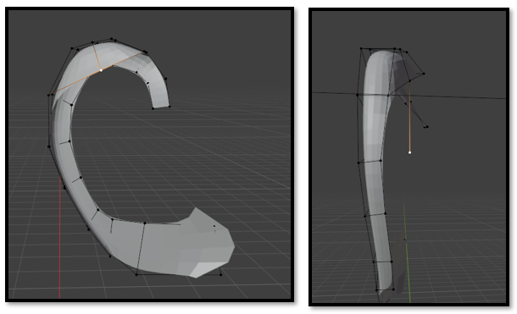

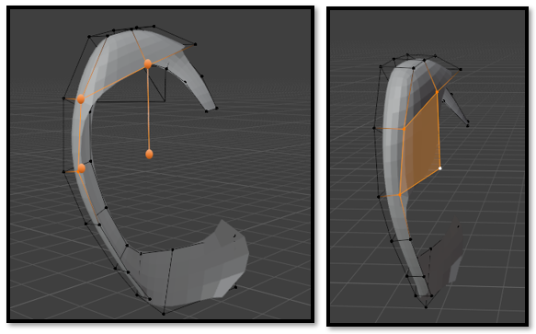

Watch It- If your topology needs to be sewn together, as most of the time, it will. You will need to get used to counting vertices on both side of the gap, as you are creating the faces. If your faces on one side do not match the vertices that you will need to be connecting to, you will find yourself in a mess.
Now look at your vertices, these two structures will have a row between them, but they will all have to have the same number of vertices between them to match.
